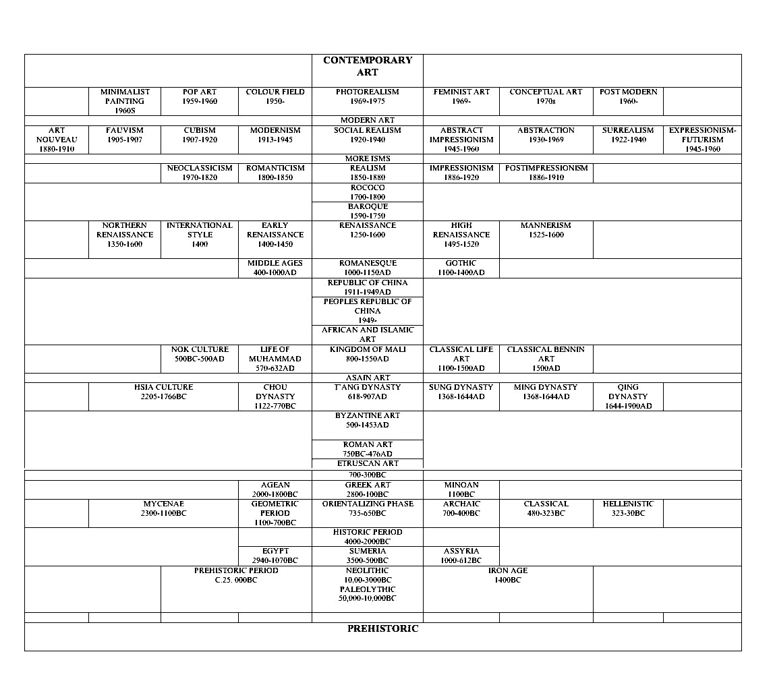TIMELINE of ART HISTORY

Name:____________________________________________________________Bell:____________
Exploring Art______________________________________________________Impressionism- Encaustic Painting
Artist Statement: Please write your answers on the back of this paper in a paragraph.
- What was easy about this project? What was difficult?
- What is something new that you learned about design or drawing that you did not know before?
- What elements of design did you emphasize on this project?
- What would you do differently to improve this project if you tried it again?
- Please make any other comments or suggestions for this project.

Name:___________________________________________________________Bell:____________________
 | 1 Limited | 2 Basic | 3 Proficient | 4 Accelerated | 5 Advanced
Content 40pts
Subject matter of at least two objects in a  still-life is recognizable –15pts | Subject matter is not recognizable |  | Subject matter is somewhat recognizable |  | Subject matter is recognizable
Subject matter is not exactly in the center of the composition—10pts | Subject matter is in the center. |  |  |  | Subject matter is not exactly in the center of the composition
Two or more objects disappear off the edges of the composition- 5pts | Two or more objects do not disappear off the edges of the composition |  | One object disappears off the edges of the composition |  | Two or more objects disappear off the edges of the composition
Light source is easy to determine by the viewer—10 pts | Not enough highlights are used to emphasize the light source |  |  |  | Light source is easy to determine by the viewer
Craftsmanship 45pts
The still-life objects are broken into pieces and then moved slightly so they create a "broken mirror" effect. 15pts | Texture is very different. |  | Some parts are smooth. Some parts are rough. |  | Texture is the same
Each "broken piece" of the still life that is created with the same amount of dark shadows on the edges and lighter values in the center.
There are parts of at least TWO different sides of each object shown. (i.e. front AND side, side AND top, top AND front, etc.)
The image that you chose to use is not pixelated.  5 pts | Image has rough or blurry edges. |  |  |  | Image has clear, sharp edges.
Highlights are emphasized to show the focal point . 15 pts | Highlights are not obvious |  | Highlights are used. |  | Highlights are used to show the focal point.
Project has been saved correctly and sent to  Ms. Sand on your Powerpoint.—10pts | Project was not sent. | Project was sent alone. |  |  | Project was sent on your Powerpoint.
Effort 5 pts
Used the ENTIRE class every  day to work |  |  |  |  | Used the ENTIRE class every day to work  (50 participation pts on Progressbook)
Students clean up tables and the floor every day. | Projects left out, materials on tables and floor, you do not clean up on time |  |  |  | Students clean up tables and the floor every day
Goal: Use your choice of tools and skills that you have mastered in Photoshop to create a still-life in the style of Cubism. Be sure to highlight the focal point!

