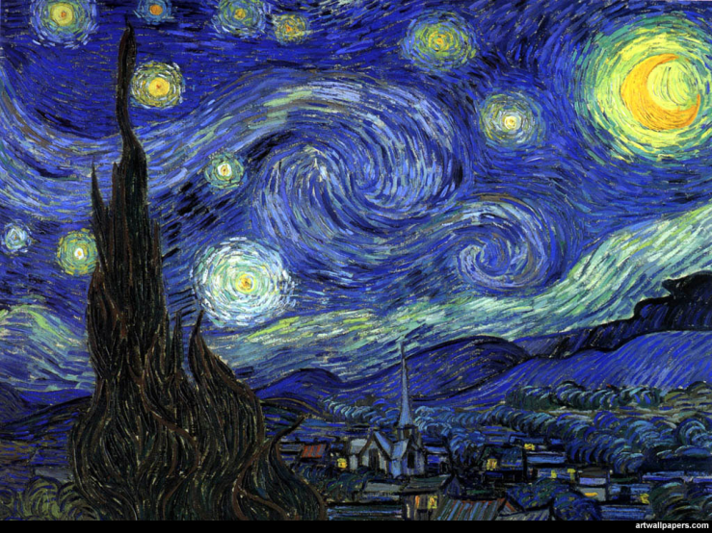
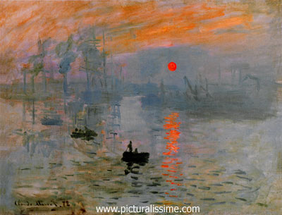Exploring Art ---–Impressionism

Post-Impressionism
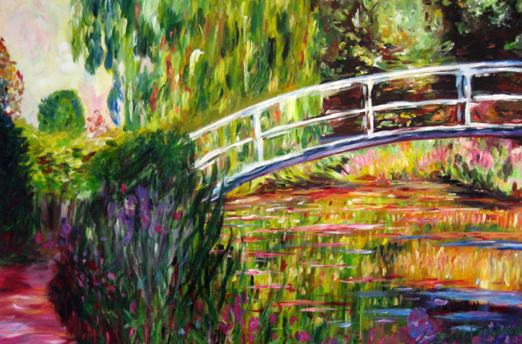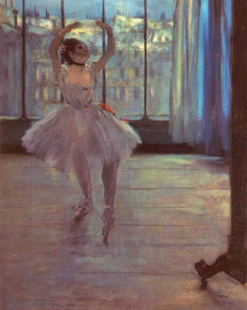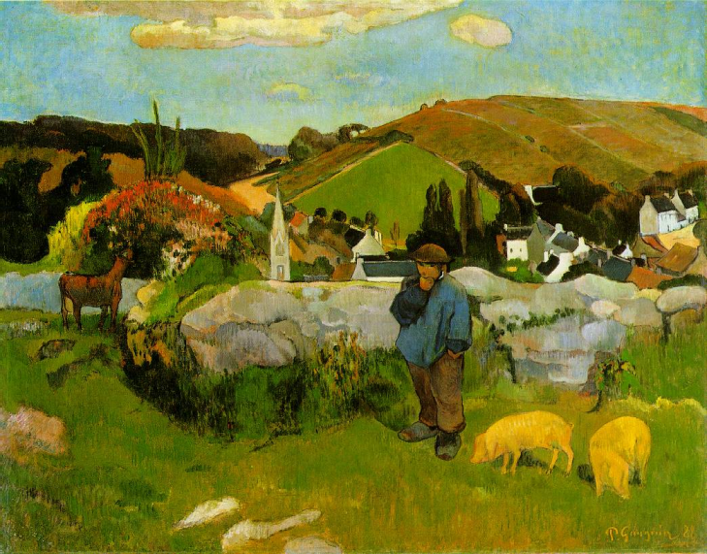

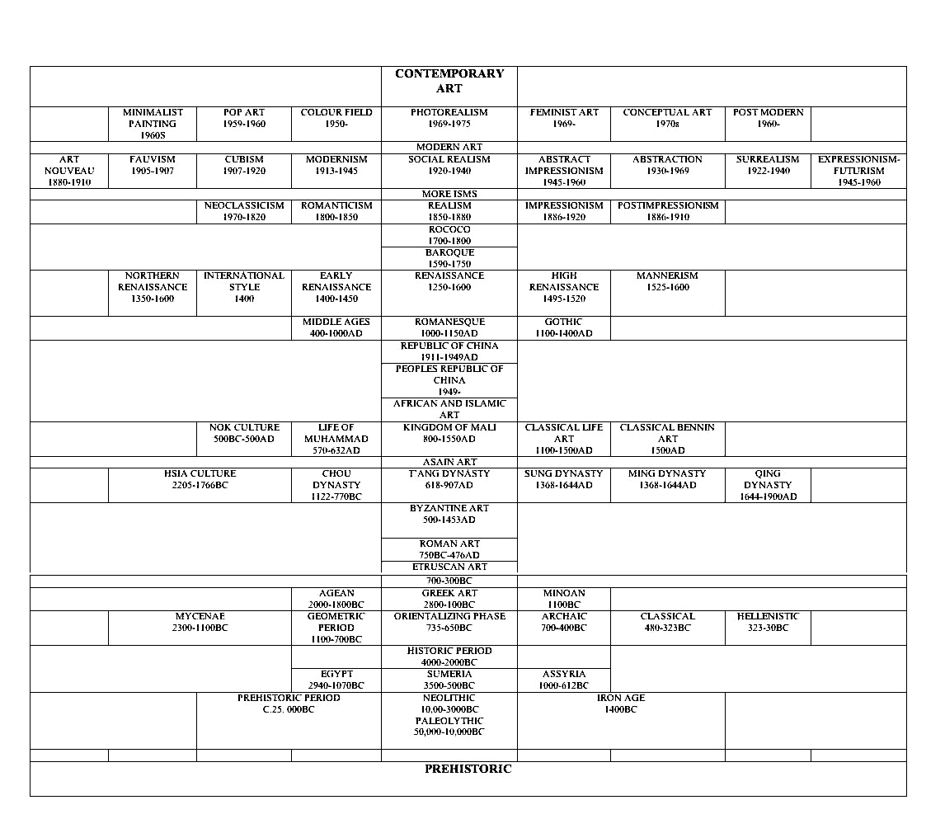TIMELINE of ART HISTORY

Name:____________________________________________________________Bell:____________
Exploring Art______________________________________________________Impressionism- Encaustic Painting
Artist Statement: Please write your answers on the back of this paper in a paragraph.
- What was easy about this project? What was difficult?
- What is something new that you learned about design or drawing that you did not know before?
- What elements of design did you emphasize on this project?
- What would you do differently to improve this project if you tried it again?
- Please make any other comments or suggestions for this project.

Name:___________________________________________________________Bell:____________________
 | 1 Limited | 2 Basic | 3 Proficient | 4 Accelerated | 5 Advanced
Content 40pts
Subject matter of a natural scene/landscape is recognizable –15pts | Subject matter is not recognizable |  | Subject matter is somewhat recognizable |  | Subject matter is recognizable
Subject matter is not exactly in the center of the composition—10pts | Subject matter is in the center. |  |  |  | Subject matter is not exactly in the center of the composition
Two or more objects disappear off the edges of the composition- 5pts | Two or more objects do not disappear off the edges of the composition |  | One object disappears off the edges of the composition |  | Two or more objects disappear off the edges of the composition
Light source is easy to determine by the viewer—10 pts | Not enough highlights are used to emphasize the light source |  |  |  | Light source is easy to determine by the viewer
Craftsmanship 45pts
The same visual texture is used throughout the composition. It is all smooth or all rough texture. 15pts | Texture is very different. |  | Some parts are smooth. Some parts are rough. |  | Texture is the same
The image that you chose is not pixelated.  5 pts | Image has rough or blurry edges. |  |  |  | Image has clear, sharp edges.
Highlights are emphasized to show the focal point . 15 pts | Highlights are not obvious |  | Highlights are used. |  | Highlights are used to show the focal point.
Project has been saved correctly and sent to  Ms. Sand on your Powerpoint.—10pts | Project was not sent. | Project was sent alone. |  |  | Project was sent on your Powerpoint.
Effort 5 pts
Used the ENTIRE class every  day to work |  |  |  |  | Used the ENTIRE class every day to work  (50 participation pts on Progressbook)
Students clean up tables and the floor every day. | Projects left out, materials on tables and floor, you do not clean up on time |  |  |  | Students clean up tables and the floor every day
Goal: Use your choice of tools and skills that you have mastered in Photoshop to create a landscape in the style of Impressionism. Be sure to highlight the focal point!

