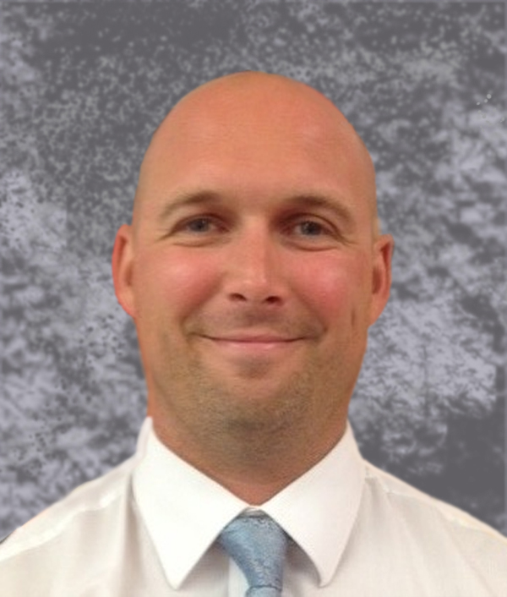

May 9, 2014

To Whom It May Concern:

My name is Kelly Rasnick and I am the Spanish I & III teacher at Princeton High School located in Cincinnati, Ohio. I am also the Princeton High School Foreign Language Co-Department Chair. I am writing to you to discuss the exceptional qualifications, talents, and professionalism of Ms. Melissa Sand in regards to her applying for a position within your school district.

I have had the honor of working closely with Melissa for over four years. Although we are in two separate departments, Melissa and I have worked closely regarding activities in and outside of our school building.

Professionally, Melissa Sand goes above and beyond her professional requirements. She puts in more than the required time during our school week focusing on building relationships with students, leading after school activities such as the Art Club, and is constantly participating in educational practices that allow her the necessary information and tools to stay current with the latest technology trends and practices within the classroom.

One of the most inspiring traits that Melissa possesses is the fact that she is not afraid of change. Melissa is constantly trying new techniques and practices in her classroom, many that she has met with great success. She sets the bar within the Art Department here at Princeton High School in regards to her classroom management and her classroom practices. The members within the Art Department value Melissa’s talents and look to her as their department chair (unofficial). Melissa serves as the Art Department liaison in our Building Leadership Team.

In regards to her involvement at Princeton High School, Melissa volunteers her time using her creative talent to assist in our school’s artistic needs. Over her years working here at Princeton High School, Melissa has been an active participant in various activities throughout our district such as helping with the creation of our S.T.E.A.M. program for our 6-12 building, designing the tickets used for both our Homecoming and Prom dances, as well as assisting in our building’s annual curriculum fair.

It is without a doubt that Ms. Melissa Sand would make an excellent faculty member in your school district. Her talents, dedication to growing professionally, and her commitment to her students is something to be admired and respected.

Sincerely,

Kelly A. Rasnick

PHS Foreign Language Co-Department Chair

Junior Student Council Coordinator

513.864.1703

krasnick@princetonschools.net

[jcruse@princetonschools.net](mailto:jcruse@princetonschools.net) Jacyln Cruse 513-864-1505

facebook: Princeton High School Vikings text wire: “Viking” to 91011 www.twitter.com/phsviking

Princeton High School

11080 Chester Road

Cincinnati, Ohio 45246

513-864-1500

www.princetonschools.net

Tryvan Leech

Grade 9

Assistant Principal

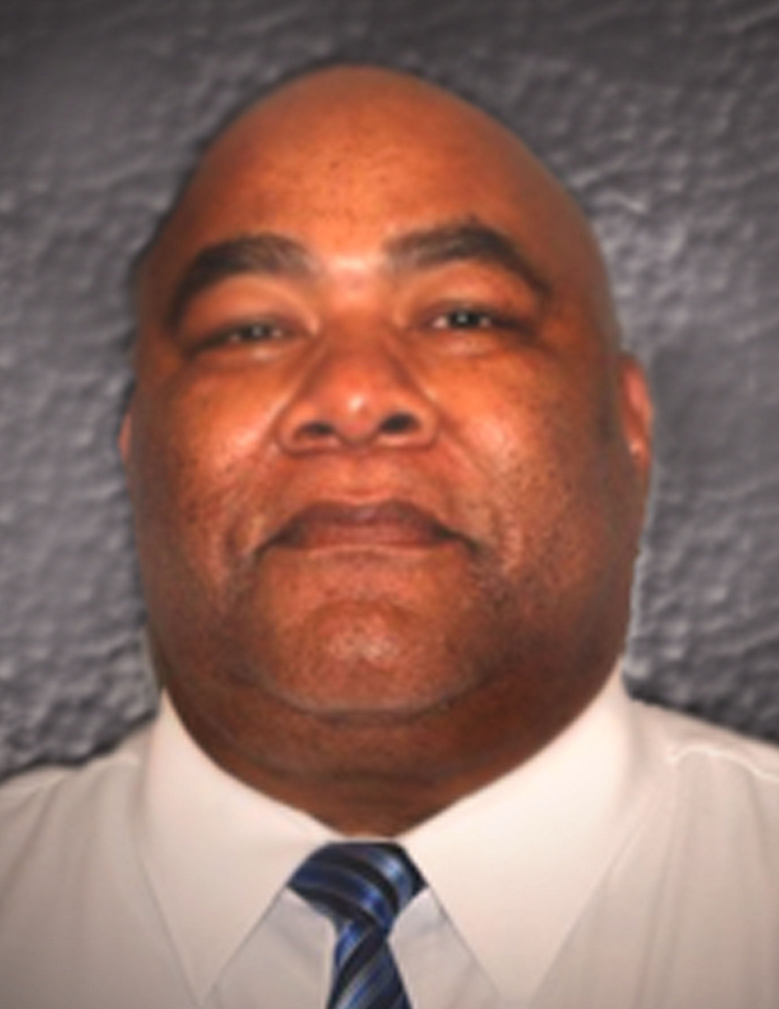

Charles Ogdan

Grade 10

Assistant Principal

Kristin Coey Grote

Upper House

Assistant Principal

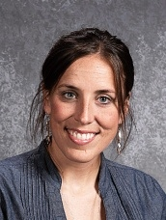

Jaclyn Cruse

Principal

